Church Opening Guidelines (COVID-19)

Phase 2 – Easing of Restrictions, 18th May 2020
The guidelines provide a set of requirements that churches would need to follow to reopen following the relaxation of lockdown laws.
Guidelines:
1. No more than 20 attendees in the church at any one time outside those required to enable the service (up to 10 persons).
2. Clear signage around service schedules, social distancing and hygiene requirements.
3. Availability of sanitiser and disinfectant wipes, and safe disposal sites.
4. Facility to be cleaned after a scheduled service or opening.
5. Maintenance of 1.5m of separation and planned entry and exit pathways.
6. Four sqm per person rule applies.
7. All attendees to provide contact details (pre bookings encouraged, plus register for walk ins).
8. No communal water station, no keep cups, no bar service and all condiments to be disposable.

COVID-19 HELP STOP THE SPREAD

Phase 2 – Easing of Restrictions, 18th May 2020

FACILITY OPENING HOURS
- Sunday 9am – 11am
- Sunday 5pm – 7pm

PERSON LIMIT
- 20 Persons
- 10 Staff / Volunteers
- Physical Distancing and 4sqm rule applies
- Contact Details

FACILITY
- Industry Clean
- Safe Hygiene

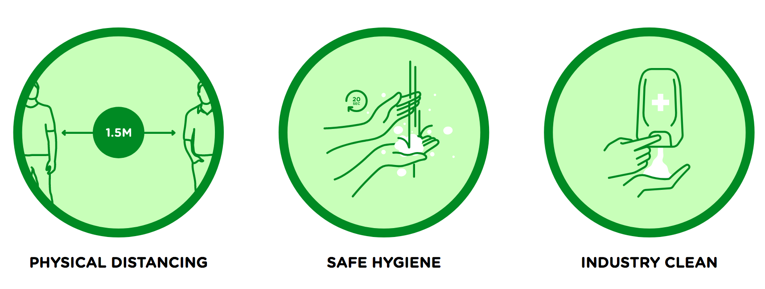

COVID-19 HEALTHY HYGIENE

Complete Hygiene Solution, by VERA
VERA is an all-in-one disinfecting formula that powerfully cleans, protects, sanitises and deodorises. The unique low-tox formula makes it safe for humans, animals and the environment.

- Plant Based, TGA Compliant
- Non-Toxic, Odourless
- All Refillable, Cost Effective & Environmentally Friendly Solution

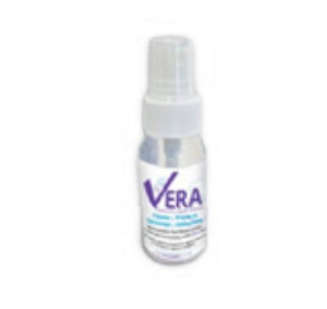 | For You and Your Team  VERA Touch 50: portable hand sprays for a safe, person-to-person, touch-friendly environment.  - Hand Disinfectant  - Immediate Surroundings Protection
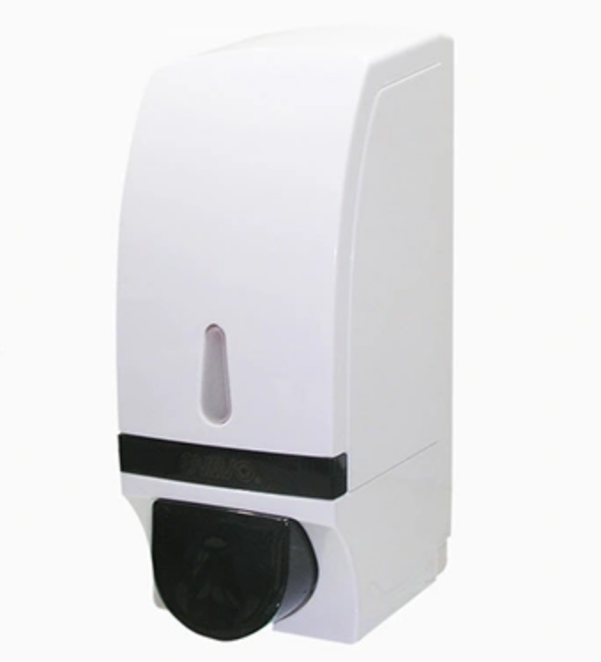 | For Attendees  VERA Touch Dispenser: wall mount hand cleanser dispenser for maximum versatility and easy access.  - Hand Disinfectant  - Functional Solution for Any Room
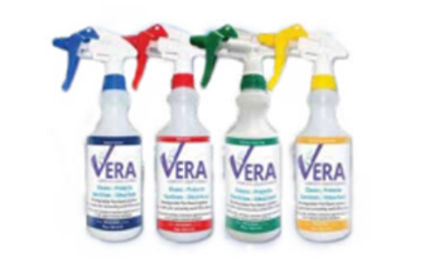 | For Facility  VERA Clean: a multi-use cleaning system for high-touch surfaces in all commercial & residential applications.  - One Simple System for All Areas  - Eliminate Cross Reaction / Cross Contamination
To place an order, call Mariana on 0410 844 518. Limited Packs Available.

